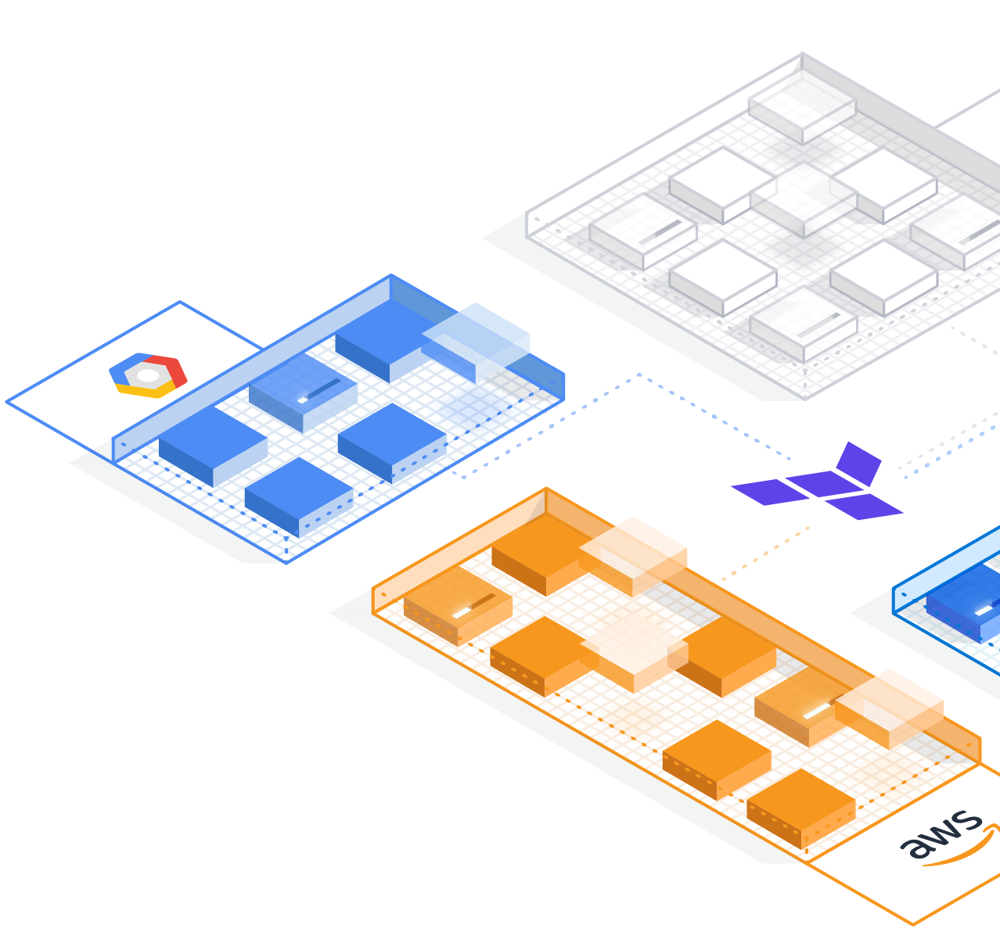

HashiCorp Validated Design

Operating Guide

Standardizing Vault

Version 1.0
Apr/2024

Intended for HashiCorp internal use only

Table of contents
Table of contents 2
Introduction 4
Prerequisites 4
Checklist 4
Use Cases Covered 5
Secure remote access with MFA No Revisions Needed - Ready to Migrate 6
Vault MFA capabilities 6
Vault Login MFA with LDAP and TOTP 7
Configuration 8
Step 1: Enable the LDAP auth method 8
Step 2: Enable login MFA method 8
Step 3: Login with the user for which MFA should be configured 8
Step 4: Generate a TOTP setup QR code 9
Step 5: Enforce MFA on LDAP login 10
Step 6: Test MFA enforcement on LDAP auth method 10
Configuration 11
Step 1: Configure the TOTP MFA method 11
Step 2: Login with the user for which MFA should be configured 12
Step 3: Generate a TOTP setup QR code 13
Step 4: Create policy enforcing MFA method on sensitive secret 13
Step 5: Test accessing the secret 14
Dynamic secretsNo Revisions Needed - Ready to Migrate 15
Dynamic secrets overview 15
Architecture and organization of dynamic secrets 16
“Root” user credential and rotation 18
Dynamic secrets engine roles 19
Database secrets engine No Revisions Needed - Ready to Migrate 20
Root credential rotation 21
Considerations for database secrets engine organization 21
Create a dynamic database role 22
View the dynamic database role 23
Generate a dynamic database credential 23
List leases and investigate a lease generated by a database role 24
Revoke leases 24
Configure a database static role 25
Other database types 26
Application considerations for dynamic credentials 27
[NOT READY TO MIGRATE] Connect applications to Vault using Vault Agent templates 28
Understanding Vault Agent templates 28
Getting Started with Vault Agent Templates 29
Common use cases for the pkiCert function to render TLS certificates 34
Integration Strategies for Applications 35
Minimizing Disruption 35
Best practices for using HashiCorp Vault Agent templates in applications 36
Operational Best Practices 37
Additional Resources 39
[NOT READY TO MIGRATE] Secrets Consumption in Kubernetes 40
Available Consumption Options 40
Which one is right for you? 42
[NOT READY TO MIGRATE] Sentinel - Enhanced access control 45
Common Scenarios 46

[READY TO MIGRATE] Introduction
This document gives recommendations on how to standardize Vault Enterprise as a shared service for your organization.

Unless specifically mentioned, concepts that apply to self-hosted Vault Enterprise also apply to HCP Vault Dedicated. However, they do not apply to HCP Vault Secrets.

HashiCorp Validated Designs provide prescriptive guidance curated from our experience supporting numerous customer journeys with Vault Enterprise.

Prerequisites
We recommend that you have completed the following steps before implementing the guidance in this document:

- Review: Vault Enterprise Operating Guide for Adoption
- Perform a maturity assessment/Architecture review with our Solution Architecture team

Checklist
After completing the maturity assessment at the end of the Adoption phase, you are ready to implement core portions of the Standardizing phase covered in this document.

While some portions of the Standardizing maturity phase are optional and will be dictated by the kind of integrations your organization requires, we recommend that all customers at the minimum adopt the following core capabilities:

- Establish a workflow for onboarding application teams to Vault
- Enable Multi-Factor Authentication (MFA) for human access to Vault (if MFA is available)
- Identify and prioritize use cases for Vault integration:
  - Integrate secrets management with legacy applications using Agent templating
  - Implement Dynamic Credentials for databases
  - Implement Dynamic Credentials for cloud access (AWS)
  - Decide on a consumption pattern for Kubernetes-based applications interacting with secrets from Vault

Use Cases Covered
This document covers the “Standardize” phase of operating Vault on the maturity scale and includes the following:

Use Case | Summary
Secure remote access with MFA | Increase security posture by adding a layer of security to human access
Dynamic secrets | Reduce the scope of exposure risk by moving from static secrets to short-lived credentials generated just-in-time
Modernize legacy applications | Retrofit existing application with Vault Agent without needing to modify the application code
Integrate Vault with Kubernetes | Multiple consumption patterns that can make integrating Vault and Kubernetes easier
Implement policy-as-code with Sentinel | Enforce policy guardrails for performing read/write activities in Vault. Advisory and mandatory enforcement to inform next steps

[READY TO MIGRATE] Secure remote access with MFA
Multi-Factor Authentication (MFA) is a system that requires more than one form of authentication to verify the identity of a user for a login or transaction. Typically implemented for governing human access to a system, MFA works by requiring any two or more of the following verification methods:
- Something the user knows (their password)
- Something the user owns (security token, one-time code, push notification)
- Something the user is (biometric information such as their fingerprint or retinal pattern)

Vault MFA capabilities
Vault incorporates two types of MFA:
- Login MFA - Additional layers of security to login workflows
- Vault Enterprise “step up” MFA - An enhanced security layer to protect sensitive API endpoints.

1. Login MFA via OpenID Connect (OIDC) or external identity provider
Many external identity providers (IDPs) like Okta or Ping Identity enable login multi-factor authentication (MFA) on their platforms. While MFA methods vary across providers, they typically mandate MFA verification during the authentication process, before granting access to applications. If an identity provider supports the OpenID Connect (OIDC) protocol, you can set up Vault's OIDC authentication method as outlined below. This setup ensures that users must complete the MFA process established at the IDP level for Vault access.

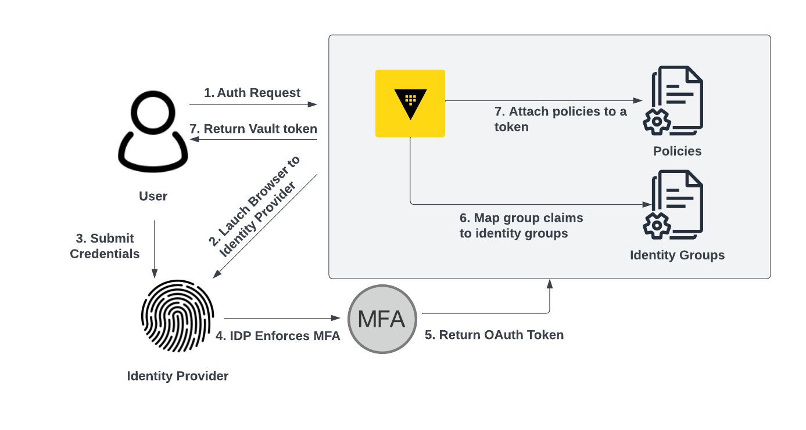
Figure 1: OIDC Auth with MFA Workflow

This approach is preferred when the IDP supports MFA because it allows you to keep all human identity management, access control, and MFA configurations in one place. It also provides scalability as your organization grows. MFA for login will only need to be configured in one place (the IDP) as opposed to separately setting up MFA in a consuming application such as Vault.

Vault Login MFA with LDAP and TOTP
The Vault operating guide HVD specifies two different human authentication methods that can be configured for organization-wide human access to Vault: OIDC and LDAP (Lightweight Directory Access Protocol). While many OIDC-compliant IDPs support implementing MFA at the identity provider level, it is less common for LDAP providers to offer native MFA support. In cases where an LDAP provider doesn't support MFA, Vault allows for MFA configurations through the LDAP method with Time-Based One-Time Password (TOTP). TOTP requires configuring a pre-shared key between Vault and a client mobile application or hardware device. The client uses a combination of the pre-shared key and the current time to generate a unique code that is only valid for a specific amount of time. This code is used as the additional factor to complete login.

Although TOTP is usually the best method when an external provider is not available, Vault also integrates with other platforms like Okta or Ping. However, it's worth noting that if Okta or Ping is accessible, the recommended approach is to configure MFA at the IDP level instead of separately within Vault to maintain unified access control and ease of management.

Due to the enrollment process involving sharing a key between Vault and an end-user’s mobile device, the TOTP method is not suitable for enrolling large numbers of users. It is therefore recommended to implement TOTP with LDAP authentication on the relatively smaller number of highly privileged users (Super administrators and regular administrators) to protect their access to Vault.

To utilize this method, a TOTP MFA method needs to be configured in Vault and associated with the organization LDAP auth method. Each user will need to enroll their device with a pre-shared key generated by Vault.

Configuration
The steps for configuration of TOTP MFA enforcement on an LDAP auth mount are listed below. Note that steps 3 and 4 will need to be repeated for each user that needs TOTP MFA setup.

Step 1: Enable the LDAP auth method
Enable LDAP prior to TOTP configuration. Refer to the Vault Operating Guide or adopting HVD document to configure LDAP authentication for your organization.

Step 2: Enable login MFA method
Enable a Login MFA method.

vault write identity/mfa/method/totp \
issuer=Vault \
period=30 \
key_size=30 \
algorithm=SHA1 \
digits=6

Note the method_id that is returned by Vault. This ID will be required to generate a QR code that will configure an end-user TOTP device.

**NOTE**: Consider the algorithms supported by your end-user authenticator application. For example, Google Authenticator for Android supports only SHA1 as the value of the algorithm. The Vault MFA API defaults to the SHA1 algorithm, if no value is supplied during configuration.

Step 3: Login with the user for which MFA should be configured
The user who needs to have MFA configured should log in to Vault.

vault login -method=ldap username=m.hashimoto password='password'

Look up the user’s token properties to capture the user’s entity_id generated by Vault.

vault token lookup

Key Value
--- -----
accessor 5LqBlBRlIIQxq8LlKshBqf7k
creation_time 1711735829
creation_ttl 768h
display_name ldap-m.hashimoto
entity_id d7e02ae4-852b-1157-a919-dcfa0762eeb3
expire_time 2024-04-26T14:10:29.798333-04:00
explicit_max_ttl 0s
id example.token
issue_time 2024-03-25T14:10:29.798336-04:00
num_uses 0
orphan true
path auth/ldap/login/m.hashimoto
policies [default]
renewable true
ttl 767h59m47s
type service



Step 4: Generate a TOTP setup QR code
Generate a PNG image of the TOTP QR code for the user. This QR Code should be scanned by the appropriate user with a TOTP generation app such as Google Authenticator. Use the TOTP method_id and user entity_id noted earlier.

vault write -field=barcode \
/identity/mfa/method/totp/admin-generate \
method_id=$TOTP_METHOD_ID entity_id=$ENTITY_ID \
| base64 -d > /tmp/qr-code.png

Delete the QR Code image after the scanning process is complete.

Step 5: Enforce MFA on LDAP login
In order to enable MFA enforcement, you will need the accessor value of the LDAP auth mount as well as the TOTP method_id noted earlier. Capture the accessor value for the LDAP auth method mount.

vault auth list --detailed

Create the enforcement by tying the MFA method_id to the LDAP auth mount accessor.

vault write /identity/mfa/login-enforcement/ldaptotp \
mfa_method_ids="$TOTP_METHOD_ID" \
auth_method_accessors=$LDAP_ACCESSOR

Step 6: Test MFA enforcement on LDAP auth method
Test the enforcement of TOTP MFA on the LDAP auth method by logging in with the Vault CLI.

vault login -method=ldap username=m.hashimoto password='password'

Enter the passphrase for methodID "a2e11225-fd33-e319-e2b1-89c13d4f9c75" of type "totp":


2.Vault Enterprise Step Up MFA
Vault Enterprise and HCP Vault feature a “step up” MFA workflow that requires a user to present an additional identity factor when issuing specific API requests, even if they have already successfully authenticated to Vault.

Guidance: In a situation where highly critical secrets are stored in Vault for human users to access, it is recommended to implement a step up MFA policy that provides additional security and identity assurance on highly critical secrets in Vault.

**Note**: Enterprise “step up” MFA cannot be configured on HCP Vault, the sys/mfa/ path is only accessible from the root namespace, which is not available to the end user in HCP Vault.

For example, if a static secret were stored at the key value path secret/topsecret/data/foo, a “step-up” MFA policy could be configured to require that any authenticated user accessing the path complete an MFA workflow, prior to being granted access to the secret. This provides additional assurance that the user accessing the path is the same user that originally authenticated, and that their Vault token has not been compromised.

For “step-up” MFA, Vault supports TOTP, Okta push notification, Duo push notification, and PIngID push notification methods. For ease of enrollment, it can be useful to leverage any pre-existing IDP MFA capabilities that may exist in your environment. However, if there are no IDP provided MFA methods available, it is recommended to implement TOTP MFA in Vault.

Configuration
This section will cover configuration of TOTP for “step-up” MFA in Vault. For other methods, steps 1, 2, and 3 will differ. However, steps 4 and 5, which link the MFA method to a specific Vault ACL policy, will remain the same for other MFA methods.
The configuration steps below assume that you already have a human auth method such as OIDC or LDAP configured on your Vault instance. Note that step 2 and 3 will need to be repeated for each user that needs to enroll in TOTP.

Step 1: Configure the TOTP MFA method
Create a TOTP MFA method that will be referenced in a Vault ACL policy to limit access to sensitive secrets.

vault write sys/mfa/method/totp/enterprise_totp \
issuer=Vault \
period=30 \
key_size=30 \
algorithm=SHA1 \
digits=6

vault read sys/mfa/method/totp/enterprise_totp

Key Value
--- -----
algorithm SHA1
digits 6
id c6fe9aa2-1f73-a5ac-9249-5cd52c658a91
issuer Vault
key_size 30
max_validation_attempts 5
name enterprise_totp
namespace_id n/a
period 30s
qr_size 200
skew 1
type totp


**NOTE**: Consider the algorithms supported by your end-user authenticator application. For example, Google Authenticator for Android supports only SHA1 as the value of the algorithm. The Vault MFA API defaults to the SHA1 algorithm, if no value is supplied during configuration.

Make a note of the id that is returned by Vault from the read command. This ID will be required to generate a QR code that will configure an end-user TOTP device.

Step 2: Login with the user for which MFA should be configured
The user who needs to have MFA configured should log in to Vault.

vault login -method=ldap username=m.hashimoto password='password'

Lookup the user’s token properties to capture the user’s entity_id generated by Vault.

vault token lookup

Key Value
--- -----
accessor 5LqBlBRlIIQxq8LlKshBqf7k
creation_time 1711735829
creation_ttl 768h
display_name ldap-m.hashimoto
entity_id d7e02ae4-852b-1157-a919-dcfa0762eeb3
expire_time 2024-04-26T14:10:29.798333-04:00
explicit_max_ttl 0s
id example.token
issue_time 2024-03-25T14:10:29.798336-04:00
num_uses 0
orphan true
path auth/ldap/login/m.hashimoto
policies [default]
renewable true
ttl 767h59m47s
type service

Step 3: Generate a TOTP setup QR code
Generate a PNG image of the TOTP setup barcode for the user. This QR code should be scanned by the appropriate user with a TOTP generation app such as Google Authenticator. Use the TOTP method_id and user entity_id noted earlier.

vault write -field=barcode \
/sys/mfa/method/totp/enterprise_totp/admin-generate \
method_id=$TOTP_METHOD_ID entity_id=$ENTITY_ID \
| base64 -d > /tmp/qr-code.png


Delete the QR image after the scanning process is complete.

Step 4: Create policy enforcing MFA method on sensitive secret
Create a policy that gates access to a sensitive secret through the previously created MFA method.

vault policy write totp-policy -<<EOF
path "secret/topsecret/data/foo" {
capabilities = ["read"]
mfa_methods = ["enterprise_totp"]
}
EOF
Note that this policy will need to be applied to the appropriate users who should have access to this secret. Configure the appropriate auth method and/or role to assign this policy to the appropriate users.

Step 5: Test accessing the secret
When reading the secret, the mfa flag needs to be supplied containing the appropriate TOTP code, otherwise Vault will not grant access to the secret.

$ vault read -mfa enterprise_totp:314643 secret/topsecret/data/foo

Key Value
--- -----
data secret-material



[READY TO MIGRATE] Dynamic secrets
Dynamic secrets are a powerful feature in Vault that allows for the generation of temporary, lease-based credentials for various services and systems. These credentials are created on-demand and have a limited lifespan, reducing the risk of credential exposure and misuse.

Dynamic secrets provide several benefits, including improved security and centralized credential management, auditing, and rotation processes. By leveraging dynamic secrets, organizations can enhance their security posture and reduce the risk of credential mismanagement.

Dynamic secrets overview
The process of generating and consuming dynamic secrets involves the following steps:
- Configure Vault: Vault needs to be configured with the appropriate secrets engine (e.g., AWS, Azure, database, etc.) and the necessary authentication and authorization mechanisms.
- Request dynamic credentials: An application or service requests dynamic credentials from Vault, specifying the desired service and any additional parameters (e.g., database name, user permissions).
- Generate and lease credentials: Vault generates temporary credentials for the requested service and associates them with a lease. The lease determines the lifetime of the credentials.
- Use credentials: The application or service can use the dynamic credentials to authenticate and access the requested service or system for as long as the lease is active
- Renew or revoke: Before the lease expires, the application can renew the credentials to extend their lifetime. Alternatively, the credentials can be revoked manually or will be automatically revoked when the lease expires.

HashiCorp Vault includes a large ecosystem of plugins to support identity and access integrations across a wide variety of external services:
- Cloud credentials - AWS, Azure, GCP
- Database credentials - Postgres, MySQL, Oracle, MongoDB, RabbitMQ etc
- Certificates - PKI
- API credentials - Kubernetes, Nomad, Consul, Terraform Cloud, etc
- Identity management - SSH, LDAP, Kerberos, Okta, GitHub, etc
- Ecosystem credentials - Artifactory, Venafi, 3rd party plugins

A list of Vault integrations can be found here: https://developer.hashicorp.com/vault/integrations.

Architecture and organization of dynamic secrets
We recommend prioritizing dynamic secrets adoption in a phased approach::
- Cloud credentials in HCP Terraform: If you use HCP Terraform to provision infrastructure, leverage Vault’s dynamic provider credentials.
- Cloud credentials in jobs, CI/CD pipelines: If you use cloud credentials embedded in jobs or CI/CD pipelines, transition to using dynamic cloud credentials.
- DB credentials in jobs, CI/CD pipelines: If you use static DB credentials in jobs or CI/CD pipelines, we recommend converting them to dynamic DB credentials.
- DB credentials in applications: Convert applications accessing sensitive databases to leverage dynamic credentials. Leverage the Vault Agent for an application that is not Vault-aware.
- PKI: Drive certificate signing and renewals.
- Third-party integrations: Where needed

Recommendation on setting the time-to-live (TTL)
Dangling leases should be avoided, due to memory consumption involved in lease management and cleanup. Tune your TTLs. Start with a generous TTL value (24-48 hrs) and fine-tune based on the application requirements and lifecycle.

Ensure batch and pipeline jobs’ TTL threshold exceeds the maximum potential of long-running jobs.

Short-lived applications should have short-lived TTLs. Long-lived leases for short-lived applications can have negative memory consequences for Vault.

Network considerations
For dynamic secrets to be implemented, Vault needs a network path to the resource being managed. Ensure your architecture supports the connection so you can adopt dynamic secrets.

In the example below, the Vault cluster is in a shared cloud account managed by the platform team. In this scenario each business unit operates a separate account with databases in their own isolated DB subnets. For adoption of Vault Dynamic DB Credentials, the following networking topology will be required.

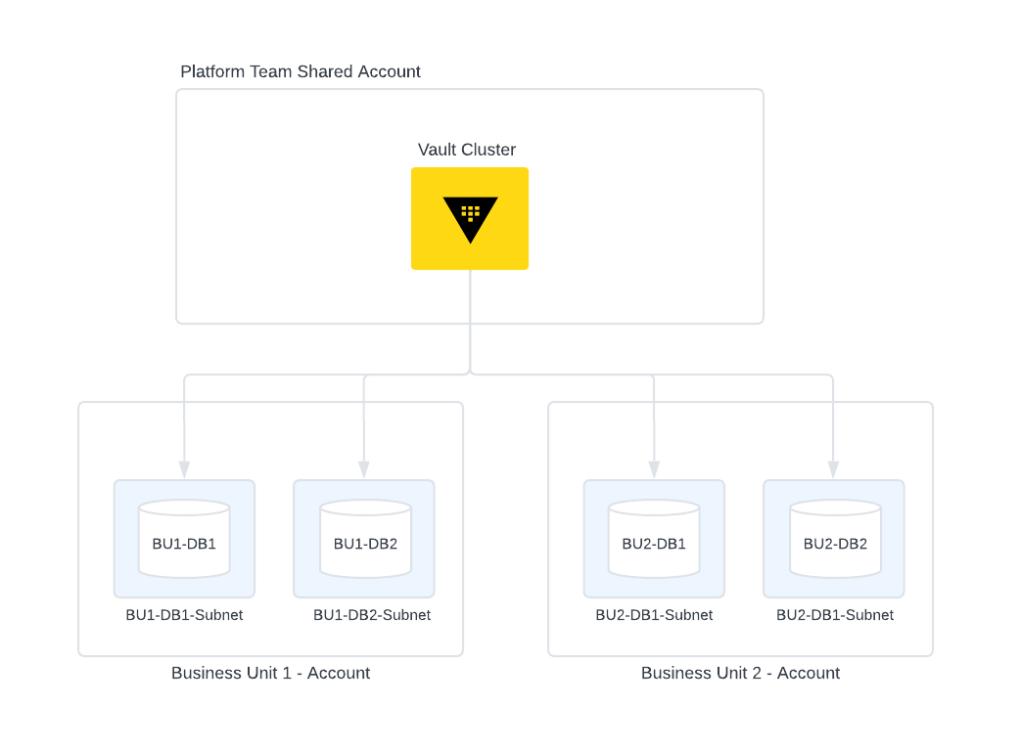
When a Vault DR/PR cluster is available, ensure that the secondary clusters have access to the tenant databases as well. This will ensure that in case of a failover, the DR/PR cluster is able to manage dynamic secrets database accounts.
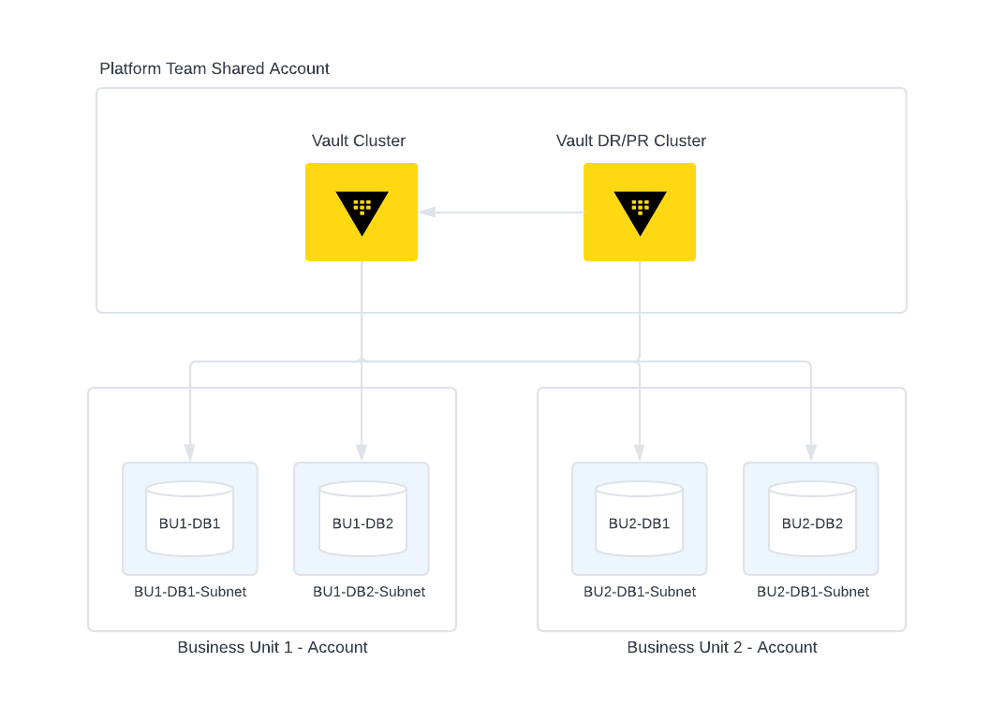

In case of region failure and the DR Vault cluster and the DR DB is promoted - please note that due to the way the DB mount is configured, the Vault DR cluster may not have a way to access the DR DB. We recommend that a separate DB mount is created for DR purposes. This also assumes that the application is configured to access the DR DB mount and has the ability to request new leases.

The connection parameter in the database secrets engine config is the key to reaching the database from Vault. By using the same client-facing FQDN or IP address for all failover replicas of your database, you can avoid configuring multiple mounts for database failover. Configure your database replication with Virtual IP addresses (VIPs), global load balancer, or DNS with failover in order to ensure access across multiple regions of Vault clusters.

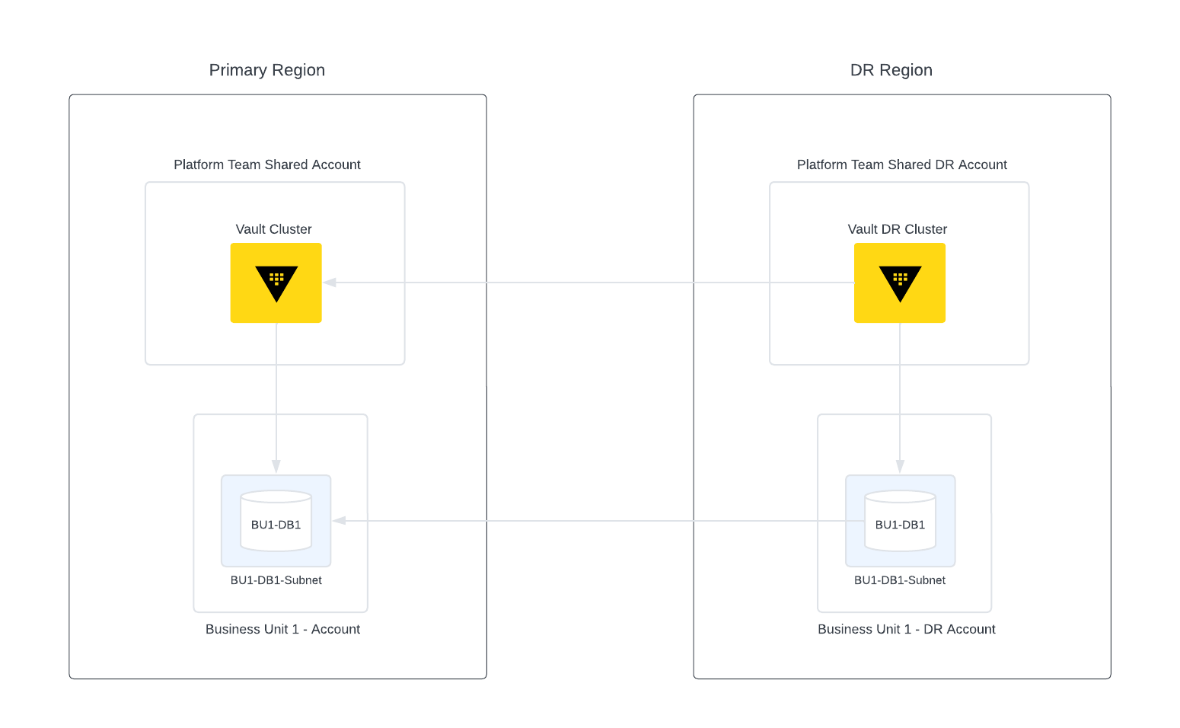

Dynamic secrets engine path
The location or mount point at which a dynamic secrets engine is activated determines specific capabilities and restrictions that impact the organization of your dynamic credentials. This includes root credential management, connection parameters, and credential roles for Vault to manage.

“Root” user credential and rotation
The “root” user in this context is a superuser service account created in an external service exclusively for Vault to manage roles. This account is then configured as the “root” user in one dynamic secrets engine in Vault.

For an AWS secrets engine, this would be an IAM user and its access key. For a PostgreSQL database secrets engine, this would be a database superuser and password. The endpoint `rotate-root` is used to manually rotate the credential of this root user. After Vault rotates the credential, there is no way to retrieve it.

There must be a 1:1 relationship between “root” users and dynamic secrets configurations in Vault. Once added to Vault, this “root” user must not be used or managed outside of Vault, and must not be used for more than one dynamic secrets engine within Vault. For the same reason, do not use the same service account for a “root” user in a secrets engine and the “root” user in an auth method.

The “root” user should have only the permissions it needs to create service accounts with their further-reduced scope. These “root” user permissions are managed in the external service. For the AWS secrets engine, the access would be defined by an AWS policy and role applied to the IAM “root” user. For the PostgreSQL database secrets engine the access would be defined by the SQL statements used to create a PostgreSQL role in the PostgreSQL database server.

Define the appropriate RBAC and account creation statements for your root and dynamic users with the help of your identity and access team and a cloud platform SME or database SME in your organization. For some examples related to specific databases, see the section of this document titled Database account creation examples.

Dynamic secrets engine roles
Role configurations are nested under a dynamic secrets engine mount path. The parameters for a role depend on the type of dynamic credential. There are two types of roles within most dynamic secrets engines. Dynamic roles are used to manage the full lifecycle of credentials in external systems. Static roles are used to manage and rotate only the secret portion of a persistent credential.

Dynamic roles are created and destroyed by Vault. A dynamic secret role configuration defines the parameters for the role, how credentials under that role are created, and the length of time a credential will be valid.

A static role configuration specifies an external credential under management, including the timing and method of rotation of its secret. Static credentials are created in the external system first and then added to Vault using an initial credential which is rotated under management.
All built-in database secrets engine plugins support both dynamic and static roles. LDAP, AWS, and GCP secrets plugins also provide static roles. The Azure secrets engine has the option to use existing service principals, although that plugin calls them `application_object_id`.

For more information about database dynamic roles, see Database Roles.

[READY TO MIGRATE] Database secrets engine
Client Cluster

Client Cluster

Database
database-app1/config/postgresql

Plugin
“Root” user and rotation statements
Connection parameters
Password policy
Allowed roles=db_app1, db1_static_app1

External service users

Client Cluster

vault_static_app1
Dynamic Role
database-app1/roles/pg_rw

db_name
TTL
username template
creation_statements
revocation_statements
credential_config

Static Role
database-app1/static-roles/pg_ro_static
db_name
rotation_statementsrotation_period
rotation_schedule
rotation_window
credential_config
1:1
1:many
1:1
vault_superuser_app1
vault_static_app1
vault_dynamic_app1_1AB39F
User1

vault_dynamic_app1_1AB39F
$ vault read database-app1/creds/pg_rw
$ vault read database-app1/static-creds/pg_ro_static
Mount Pathdatabase-app1

Config
The `config/:name` endpoint of a database secrets engine includes settings to configure each database connection and type. These parameters are defined by the database plugin being used, so they may differ between various databases. The `name` used here must be re-used by the roles that leverage this connection.

For more information, see the server and API documentation: https://developer.hashicorp.com/vault/docs/secrets/databases and
https://developer.hashicorp.com/vault/api-docs/secret/databases#configure-connection

Example configuration
$ export POSTGRES_URL=127.0.0.1:5432

$ vault write database-app1/config/postgresql \ plugin_name=postgresql-database-plugin \
allowed_roles=pg-ro,pg-rw,pg-static \
connection_url="postgresql://{{username}}:{{password}}@$POSTGRES_URL/demoapp?sslmode=disable" \
username=db_admin_vault \
password=insecure_password

Success! Data written to: database-app1/config/postgresql


Root credential rotation
To secure Vault’s “root” credential after it is configured, Vault provides an endpoint to rotate the credential. This will replace the manually-entered credential with a credential that only this Vault configuration knows. For this reason, do not use the same “root” credential in more than one location, even within the same Vault cluster. Immediate root credential rotation reduces risk of someone else accessing and using that credential.

$ vault write -force database-app1/rotate-root/postgresql


Considerations for database secrets engine organization
You can configure multiple database plugins per mount point, by writing different configs for different database plugins, with distinct connection parameters. If you have multiple database types configured under one mount path, use the `allowed_roles` parameter to restrict which plugin is used by each role.

Configuring multiple database types and connections under one mount point has some pros and cons. Doing so can consolidate configuration of Vault policies for an app that happens to use multiple database connections. However, providing multiple database connections under one mount point could lead to inadvertent mismanagement, such as revoking credentials across multiple databases accidentally, or requesting the wrong credential altogether. It also could add forensic complexity during an audit.

Configuring a secrets engine path per application enables management of one application's secrets separately from other applications’ secrets, isolating policy management, root credentials, and credential lifecycle management.

For these reasons, it is generally a best practice to create one secrets engine mount point per database, per application.

Database Roles
Roles define the credential generation of the database secrets engine. You can have multiple roles per database configuration. For example, you may want both read-only and read-write roles for a PostgreSQL server. The same Vault “root” user will require appropriate capabilities in the database to manage all roles that use the same database configuration.

Database roles have creation_statements which define what SQL statements will be executed by Vault when it connects to the database to create a role.

Username customization is a feature to improve visibility within the database. For example, you can prepend roles with ‘vault_managed’ to make it more clear to database engineers which roles are managed exclusively via Vault. This can help prevent accidental deletion of Vault’s managed accounts.

Configurable password policies enable you to meet your organization’s complexity requirements for compliance. Password policies can be defined at the database configuration level, and the role level, enabling the ability to inherit or override the password policy for each database role.

Create a dynamic database role
First, you need to define the creation statements for your role. The creation statements should be determined in conjunction with your database administration, security, and IAM teams as appropriate for your organization. The database team may provide the statements to you in a file. This example writes statements to a local file, defining broad read-only access:

$ tee readonly.sql <<EOF
CREATE ROLE "{{name}}" WITH LOGIN PASSWORD '{{password}}' VALID UNTIL '{{expiration}}';
COMMENT on ROLE "{{name}}" IS 'Role managed by Vault';
GRANT CONNECT ON DATABASE demoapp TO "{{name}}";
GRANT SELECT ON ALL TABLES IN SCHEMA public TO "{{name}}";
EOF

The next command creates the role in Vault, using the statements from a file. The db_name value must match the name of the database secrets engine object created earlier (not the database hostname). In this example, it is postgresql.

$ vault write database-app1/roles/pg-ro \
db_name=postgresql \
creation_statements=@readonly.sql \
default_ttl=1h max_ttl=24h

Success! Data written to: database-app1/roles/pg-ro


View the dynamic database role
You can read the same role endpoint to view the role configuration and SQL statements.

$ vault read database-app1/roles/pg-ro

Key Value
--- -----
creation_statements [CREATE ROLE "{{name}}" WITH LOGIN PASSWORD '{{password}}' VALID UNTIL '{{expiration}}';
COMMENT on ROLE "{{name}}" IS 'Role managed by Vault';
GRANT CONNECT ON DATABASE demoapp TO "{{name}}";
GRANT SELECT ON ALL TABLES IN SCHEMA public TO "{{name}}";]
credential_type password
db_name postgresql
default_ttl 1h
max_ttl 24h
renew_statements []
revocation_statements []
rollback_statements []


Generate a dynamic database credential
To create a new dynamic credential, you need to perform a read against the credential endpoint for the role.

$ vault read database-app1/creds/pg-ro

Key Value
--- -----
lease_id database-app1/creds/pg-ro/6XNimuvRkRgQqMoKHUdXigII
lease_duration 1h
lease_renewable true
password -upnMCdrAyBdl0MwRjcS
username v-root-pg-ro-55zd1HKtF4qzsqQiEklO-1712362373


List leases and investigate a lease generated by a database role
Note that the lease_id from the above command matches the output in this command. In this example, there is only one active lease:

$ vault list sys/leases/lookup/database-app1/creds/pg-ro

Keys
----
6XNimuvRkRgQqMoKHUdXigII

$ vault lease lookup database-app1/creds/pg-ro/6XNimuvRkRgQqMoKHUdXigII

Key Value
--- -----
expire_time 2024-04-05T20:12:53.168521-05:00
id database-app1/creds/pg-ro/6XNimuvRkRgQqMoKHUdXigII
issue_time 2024-04-05T19:12:53.168518-05:00
last_renewal <nil>
renewable true
ttl 50m47s


Revoke leases
The following command will revoke one lease, deleting its related database credential:

$ vault lease revoke database-app1/creds/pg-ro/6XNimuvRkRgQqMoKHUdXigII

By comparison, this command will revoke all leases under the `pg-ro` role (and delete all related database credentials):

$ vault lease revoke -prefix database-app1/creds/pg-ro

Even more destructively, the following command deletes all credentials for all dynamic roles under the database-app1 mount path:

$ vault lease revoke -prefix database-app1/creds/


Static Roles
Static roles are used to rotate the secret password component of a database login credential, while maintaining the same username portion. Using static roles enables Vault operators to rotate passwords without needing to create and delete users from the database. This can be important for performance at scale, since creating and deleting users can cause table locks impacting database performance. Static roles can be rotated based on a cron-like schedule, and limited to a window of time.

Configure a database static role
The static database role must already exist in the remote database. Vault will immediately rotate the password when the role is configured.

The Vault “root” user must have RBAC that allows it to ALTER the static role to change the password. Then, set up a file with rotation statements:

$ tee rotation.sql <<EOF
ALTER USER "{{name}}" WITH PASSWORD '{{password}}';
EOF

Then the static role can be connected to Vault:

$ vault write database-app1/static-roles/pg-static \
db_name=postgresql \
rotation_statements=@rotation.sql \
username="vault_static_app1" \
rotation_period=86400

Read the static role’s password, which will stay the same until it is rotated:

$ vault read database-app1/static-creds/pg-static

Key Value
--- -----
last_vault_rotation 2024-04-05T20:07:45.462742-05:00
password B8uk8rmn6cFiIvOZ-trN
rotation_period 24h
ttl 23h59m47s
username vault_static_app1


Other database types

AWS DynamoDB - AWS Secrets Engine
While DynamoDB is not supported by the database secrets engine, you can use the AWS secrets engine to provision dynamic credentials capable of accessing DynamoDB.

More information can be found here: https://developer.hashicorp.com/vault/docs/secrets/databases#aws-dynamodb

IBM DB2
Access to Db2 is managed by facilities that reside outside the Db2 database system. By default, user authentication is completed by a security facility that relies on operating system based authentication of users and passwords. This means that the lifecycle of user identities in Db2 aren't capable of being managed using SQL statements, which creates an operational challenge for credential lifecycle management.
To provide flexibility in accommodating authentication needs, Db2 ships with authentication plugin modules for LDAP.
More information about using Vault to manage DB2 credentials can be found here: https://developer.hashicorp.com/vault/tutorials/db-credentials/ibm-db2-openldap

Application considerations for dynamic credentials
Applications will need to be aware of password rotation in certain cases, especially for long-running jobs and applications.

For example, in the case of Spring Boot applications, you would do the following:
- Configure Spring Cloud Vault: Set up Spring Cloud Vault in your application.properties or application.yml file, specifying the necessary configurations to connect to Vault and access the dynamic secrets.
- Enable refresh scope: For any beans that should be refreshed when the configuration changes, use the @RefreshScope annotation. This might include your DataSource bean or any configuration properties class that holds your database credentials.
- Enable Actuator refresh endpoint: Make sure the Actuator's refresh endpoint is enabled and exposed. In Spring Boot 2.x, this might involve setting properties in your application.properties or application.yml, like
management.endpoints.web.exposure.include: refresh
- Create a refresh mechanism: Implement a mechanism to call the /actuator/refresh endpoint whenever the credentials in Vault are rotated. This could be a scheduled task within your application, an external script, or a webhook triggered by Vault (if Vault is configured to send notifications on credential rotation).
- Secure the Actuator endpoints: Ensure that your Actuator endpoints, including the /refresh endpoint, are secured to prevent unauthorized access. Use Spring Security to restrict access to these endpoints.
- Refresh DataSource credentials: Ensure your DataSource or the component that manages the database connection is designed to handle configuration changes dynamically. This might involve using a DataSource proxy or custom logic to reinitialize the DataSource with new credentials upon refresh. Here is a simplified example demonstrating how you might configure a DataSource bean to use dynamic credentials that can be refreshed via Actuator:

@Configuration
public class DataSourceConfig {
@Bean
@RefreshScope
public DataSource dataSource(
@Value("${spring.datasource.url}") String url,
@Value("${spring.datasource.username}") String username, @Value("${spring.datasource.password}") String password) {
return DataSourceBuilder.create()
.url(url)
.username(username)
.password(password)
.build();
}
}

[READY TO MIGRATE] Connect applications to Vault using Vault Agent templates
Vault Agent templates offer a seamless way to integrate secrets management into your applications both new and old/legacy. For legacy (existing) applications, Vault agent brings the benefit of modern secrets management bypassing the need for application upgrades or modifications. These agents authenticate with Vault, retrieve secrets, and inject them where your application expects, either as an environment variable or file, facilitating secret consumption and refreshment in sync with the application's lifecycle.

Understanding Vault Agent templates

Vault Agent templates bridge the gap between the secret's format in Vault and the application's expectations. For instance, consider an application that uses a credentials file like this:

```
Password=passwordxyz,
Username=userxyz
```

Vault’s API responses look like this:

```
"Password": "passwordxyz",
"Username": "userxyz"
```


Agent templates allow you to reformat this data, ensuring it aligns with the application's required input format.

Getting Started with Vault Agent Templates

<Note>
Vault Agent leverages the same templating engine used by Hashicorp Consul and other HashiCorp products. For more details on the templating engine, see the consul-template public GitHub repository.
</Note>

To demonstrate the components of templates, we will create a template that renders a file in a format that another application expects, populated with secret information from Vault. Given an existing secret in Vault like this:

$ vault read database-app1/creds/pg-ro

Key Value
--- -----
lease_id database-app1/creds/pg-ro/2f6a614c-4aa2-7b19-24b9-ad944a8d4d
lease_duration 1h
lease_renewable true
password FSREZ1S0kFsZtLat-y94
username v-vaultuser-e2978cd0-ugp7iqI2hdlff5hfjylJ-1602537260


We would expect the final rendering of the secret within the destination to be:

DBUser:v-vaultuser-e2978cd0-ugp7iqI2hdlff5hfjylJ-1602537260
DBPassword:FSREZ1S0kFsZtLat-y94


Template language overview

Templates are defined using Go's templating format. First, we define a `template_config` block in our agent configuration to control template interactions. This block, set globally, specifies error handling and render intervals for static secrets:

template_config {
exit_on_retry_failure = false
static_secret_render_interval = "5m"
}

The above serves as an example of how the configuration can be changed and is based on the original default value.

<Note>
The rendering frequency for both static and dynamic secrets is specified based on whether it is a leased and/or renewable secret. Each combination has its own default configuration for when the rendering will happen. In most cases, the default setting should be sufficient. Otherwise, those configurations can be re-configured as indicated here.
</Note>

Next, we define how to format the rendered secret within a `template` stanza. This stanza is specifically for manipulating a secret pulled from the Vault server and formatting in a way the consuming application expects:

template {
source = "/tmp/agent/template.ctmpl"
destination = "/tmp/agent/render.txt"
}

This configuration specifies the source template file and the destination file for the rendered output.

<Tip>
It is possible to render multiple secrets to a specific destination file within the same template. This is applicable in scenarios where you have a single application config file containing multiple secrets. Likewise, it is also possible to define multiple template stanzas within the same agent configuration file secrets for the creation of multiple destination files.
</Tip>

The source value in the template stanza references a templating file (.ctmpl) that specifies the Vault secret to retrieve and its formatting. The type of secret dictates the function used to declare it in the template.

The .ctmpl file should resemble the following:

{{ with secret "database-app1/creds/pg-ro" }}
DBUser:{{ .Data.username }}
DBPassword:{{ .Data.password }}
{{ end }}

The template's first line declares the secret function, essential for processing most Vault secrets, excluding PKI certificates (we'll cover this exception later). The rest is written normally in the format of the destination file, using curly braces to break out into rendering the secret as needed. Any characters that fall outside of the curly braces will be taken literally. When a secret is pulled from Vault, it is returned as a JSON-based payload.

<Tip>
If there are errors in the templating engine, directly make an API call to Vault and examine the JSON payload to ensure that the template's configuration aligns with the response received from Vault.
</Tip>

A full list of parameters for the template block can be referenced here.

For simpler scenarios where maintaining a separate template file is excessive, embed the template directly using the contents parameter in place of source:

template {
contents ="{{ with secret \"database-app1/creds/pg-ro\" }}DBUser:{{ .Data.username }}\nDBPassword:{{ .Data.password }}{{ end }}"
destination ="/tmp/agent/render.txt"
}



Environment variables

For environment variable injection, use `env_template` stanzas. In this case, the name of the block (the string following `env_template`) will become the rendered environment variable. Because of this, no destination parameter is needed within env_template stanzas:

env_template "DB_USER" {
contents = "{{ with secret \"database-app1/creds/pg-ro\" }}{{ .Data.username }}{{ end }}"
}

env_template "DB_PASSWORD" {
contents = "{{ with secret \"database-app1/creds/pg-ro\" }}{{ .Data.password }}{{ end }}"
}

The full list of parameters for env_template can be found here.

Application memory

Some applications retrieve secrets directly from memory, not from files or environment variables. In these cases, it is recommended to use Vault Agent's Process Supervisor Mode. In this mode, Vault Agent will inject secrets referenced in the env_template configuration blocks as environment variables into the child process specified in the exec block.

<Note>
It is necessary for the target application to be run as a subprocess of Vault Agent (via exec) in order for Vault Agent to inject secrets into the target application’s environment variable. In many ways, Vault Agent will mirror the child process. Standard input and output streams (stdin / stdout / stderr) are all forwarded to the child process. Additionally, Vault Agent will exit when the child process exits on its own with the same exit code.
</Note>

Vault Agent’s Process Supervisor mode is used when you define env_template and a separate exec block to perform the additional necessary command. This block is executed after all env_template have been rendered and will be executed again during any re-rendering of the env_template (e.g., secret rotation and update) :


env_template "DB_USER" {
contents = "{{ with secret \"database-app1/creds/pg-ro\" }}{{ .Data.username }}{{ end }}"
error_on_missing_key = true
}

env_template "DB_PASSWORD" {
contents = "{{ with secret \"database-app1/creds/pg-ro\" }}{{ .Data.password }}{{ end }}"
error_on_missing_key = true
}

exec {
command = ["./my-app", "arg1", "arg2"]
restart_on_secret_changes = "always"
restart_stop_signal = "SIGTERM"
}

<Tip>
It is recommended to set error_on_missing_key = true so that the Vault Agent will log an error when accessing a secret that does not exist. The error message will help during the debugging of the Vault Agent configuration. When error_on_missing_key is not specified or set to false (the default) and the key to render is not in the secret's response, the templating engine will ignore it (or render "<no value>") and continue with its rendering.
</Tip>

PKI certificates

In the examples so far, we've used the secret function within the template stanza for retrieving secrets, However, PKI certificates require additional considerations, due to their inherent lifecycles and expiration details. Vault Agent provides a specific `pkiCert` template function to aid in the management of both the token/lease lifecycle and the certificate's expiration. This changes the behavior of when the agent refreshes the certificate, and how the agent will behave when it is restarted (e.g., whether to fetch an updated certificate or not based on the expiration of the certificate itself).

Here are some behavior differences to be aware of when working with PKI certificates:

- If a certificate is configured to be rendered using the pkiCert template function, Vault Agent will perform a check during agent startup to detect if there is an existing certificate. If none has been previously rendered or the current rendered certificate has expired, Vault Agent will fetch a new certificate. This same check is performed during the agent auto-auth re-authentication.

- If a certificate is rendered using the secret template function, Vault Agent will fetch a new certificate on agent startup, even if previously rendered certificates are still valid. This is also true during agent auto-auth re-authentication.

- In addition, if generate_lease is unset or set to false, the agent will use the certificate's validTo field to decide when to rotate the certificate. If generate_lease is set to true, the agent will follow the non-renewable, leased secret rules.

As a result of the above behavior with secret, it is therefore recommended to use pkiCert to render the PKI certificates so as to avoid creating unnecessary certificates even when the existing has not expired.

Common use cases for the pkiCert function to render TLS certificates

To generate a new certificate and create a bundle with the key, certificate, and CA, use:

{{ with pkiCert "pki/issue/my-domain-dot-com" "common_name=foo.example.com" }}
{{ .Data.Key }}
{{ .Data.Cert }}
{{ .Data.CA }}
{{ end }}


To fetch only the issuing CA for this mount, use:

{{- with secret "pki/cert/ca" -}}
{{ .Data.certificate }}
{{- end -}}


<Tip>In the above example, pki/cert/ca_chain can be used instead to fetch the full CA chain.</Tip>

Integration Strategies for Applications

Minimizing Disruption
As with any change in an environment, configuration changes on Vault Agent such as templates should be tested in a development environment and rolled up to QA/Prod in stages to minimize the chance of an outage. Error handling while reviewing in a dev environment is key to shield against possible issues such as (but not limited to):

- Agent process suddenly being stopped
- Application being stopped
- Reboots / Power outages
- Vault server unavailability
- File system permissions

Best practices for using HashiCorp Vault Agent templates in applications

Always use least-privilege access
Ensuring least privilege access is always best practice. As Vault Agent is a client of Vault server, consider the authentication method used by auto-auth and the ACL policy that is assigned upon successful authentication.

Error Handling

The base template_config stanza will be the first location to add some error handling, the only parameters available within this block are:

- exit_on_retry_failure (bool: false) - This option configures Vault Agent to exit after it has exhausted its number of template retry attempts due to failures.
- static_secret_render_interval (string or integer: 5m) - If specified, configures how often Vault Agent Template should render non-leased secrets such as kvv2. This setting will not change how often Vault Agent templating renders leased secrets. Uses duration format strings.

- exit_on_retry_failure as a global parameter is a general catch-all which will go on a retry loop. Error handling can also be added within the template stanza while the secret is being processed to exit. An example of this is using error_on_missing_key within the template stanza.

- error_on_missing_key (bool: false) - Exit with an error when accessing a struct or map field/key that does not exist. The default behavior will print <no value> when accessing a field that does not exist. It is highly recommended you set this to true.

<Note>
If error_on_missing_key is set to false or missing from the stanza, the templating will still attempt to render. If the expected payload is missing, the resulting destination will be blank.
</Note>

Operational Best Practices

Monitoring and Logging

If the Vault Agent process is stopped or dies, applications will continue functioning with previously rendered secrets. However, it can still lead to issues, particularly if dynamic secrets with shorter life cycles are being used. Because of this, monitoring the health of Vault Agent and alerting on failures is crucial, especially as the number of applications using Vault Agent grows over time.

To address the above, Vault Agent has a telemetry feature that can be configured using the telemetry stanza to offer operational insights. As the telemetry stanza is exactly the same as those used to configure Vault Server telemetry, it is possible to leverage the same telemetry sinks used in your Vault Server deployment such as Prometheus, StatsD, or InfluxDB.

Vault Agent Telemetry provides the following runtime metrics about its performance, the auto-auth and the cache status:

Metric | Description | Type
vault.agent.auth.failure | Number of authentication failures | counter
vault.agent.auth.success | Number of authentication successes | counter
vault.agent.proxy.success | Number of requests successfully proxied | counter
vault.agent.proxy.client_error | Number of requests for which Vault returned an error | counter
vault.agent.proxy.error | Number of requests the agent failed to proxy | counter
vault.agent.cache.hit | Number of cache hits | counter
vault.agent.cache.miss | Number of cache misses | counter

For active monitoring of the operation logs, logging can be configured during the starting of the agent or specified in the configuration file. Vault Agent supports various verbosity levels such as trace, debug, info, warn, and error (in order of descending detail). It is recommended to keep the default verbosity level (“info”) unless there are specific needs, such as during debugging, where you might need the debug or trace verbosity level for more detailed logs.

Just as with telemetry, it is recommended to integrate Vault Agent logging with your enterprise logging solution (if applicable) so the Vault logs can be consolidated and made visible through a centralized logging platform. Depending on your enterprise logging solution, it is also recommended to set up alerts for any logs indicating warnings or errors.

Common Issues and Solutions

- Customers sometimes encounter challenges when generating a Vault Agent's configuration file. A practical starting point is to use the agent binary's generate-config flag, which can help you create a basic configuration file. However, this initial setup typically needs fine-tuning before it is suitable for use in production, especially regarding things like authentication configuration or integrating different secret engines.

- If you find you need help debugging your template, you can monitor the agent log by setting the log-level to trace. This log level can provide useful data if you are experiencing issues initiating agent process, or if your secret is not being rendered correctly.

Additional Resources
- Links to relevant existing support articles or other HashiCorp documentation (optional section: integrate links throughout content wherever possible)
  - https://developer.hashicorp.com/vault/docs/agent-and-proxy/agent/template
  - https://developer.hashicorp.com/vault/docs/agent-and-proxy/agent/process-supervisor#env_template
  - https://github.com/hashicorp/consul-template/blob/main/docs/templating-language.md
  - https://developer.hashicorp.com/vault/docs/agent-and-proxy/agent
  - https://developer.hashicorp.com/vault/api-docs/secret/pki

[READY TO MIGRATE] Secrets Consumption in Kubernetes
HashiCorp Vault has an operator, sidecar container, and daemonset options available to provide flexible consumption of secrets in Kubernetes environments. Each of these provide different features, and advantages and disadvantages depending on how the Platform Team manages Kubernetes within the organization.

Available Consumption Options

Vault Secrets Operator (VSO)
The Vault Secrets Operator manages secrets on Kubernetes using Vault. The primary utility of the Operator lies in its ability to facilitate the consumption of secrets as native Kubernetes secrets. The Operator renders secrets natively as Kubernetes Secrets. The Operator also provides full secrets lifecycle management, including static and dynamic secrets from the Vault server. The Operator is also capable of managing the rotation of secrets, and notifying applications via rolling updates of a Deployment.
The Vault Secrets Operator supports a variety of authentication methods.

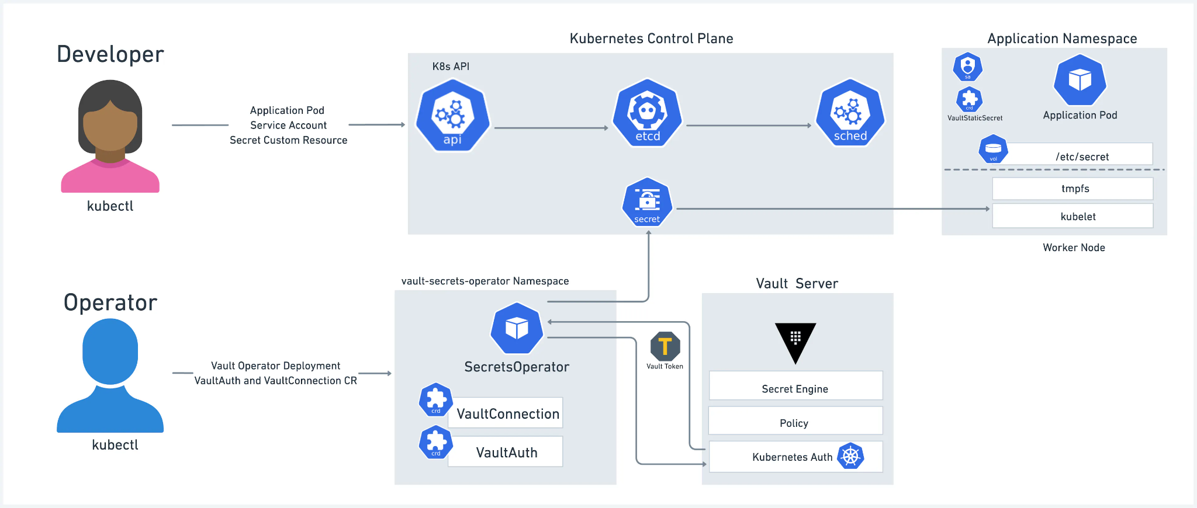

Vault Agent Sidecar Injector
The Vault Agent Sidecar Injector is designed to inject Vault secrets into your applications without requiring the applications to interact with Vault directly. The Agent Sidecar Injector accomplishes this by rendering Vault secrets to shared memory volumes. This approach offers remarkable convenience by allowing containers within a pod to consume secrets without being made Vault-aware. The Vault Agent sidecar Injector functions as a Kubernetes mutating webhook service, intercepting pod events and injecting Vault Agent container(s) into the pod if specific annotations exist on the resource. The Vault Agent Sidecar Injector is a part of the vault-k8s project and can be installed with the Vault Helm chart.
The Vault Agent Sidecar injector supports all authentication methods available to Vault Agent.
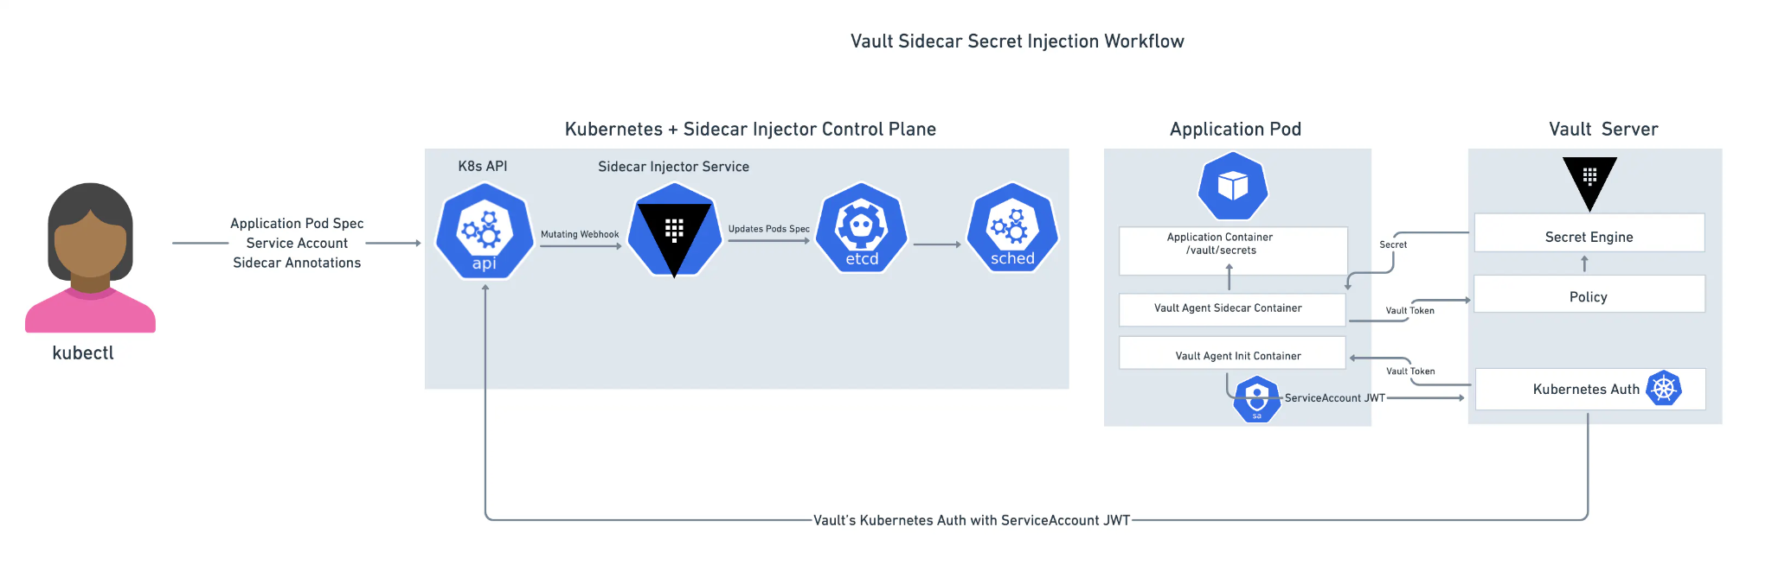

CSI Provider
The Vault CSI Provider provides secrets to applications running within Kubernetes, operating as a daemonset as opposed to a sidecar within each pod. The CSI Provider utilizes standard Kubernetes CSI Secrets Store volumes. Functionally, a user creates a SecretProviderClass object which specifies `vault` as the secret provider and contains the auth details and secrets to retrieve from Vault. When a Pod is created that references that SecretProviderClass, the Vault CSI provider uses that information along with the pod's service account to retrieve and mount secrets into the pod's CSI volume." This is a blocking operation, as secrets must be retrieved and populated during the ContainerCreation phase, so a pod will not start until the secret has been read and written to the volume.
The CSI Provider supports Kubernetes and JWT authentication methods.
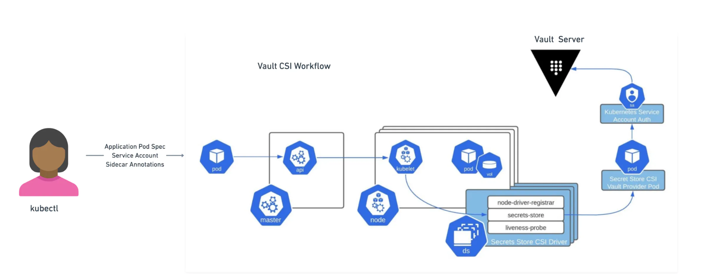

Which one is right for you?
While these solutions all enable the consumption of Vault-managed secrets from applications running in Kubernetes, there are considerations that may inform your organization’s approach. A hybrid solution may also be appropriate.

- Secret projections - How applications expect secrets to be presented is important. Typically, applications will expect an environment variable, or a file that can be read during startup.
- Secret types - Secrets can be a variety of different formats, static and dynamic, leased and/or renewable secrets. Taking these into account helps teams understand how they will be projected into applications.
- Governance - In some scenarios, applications and secrets may have many-to-many relationships that require a specific secret to be consumed by multiple applications. As such, it makes sense to leverage an integration approach that is compatible with Kubernetes secrets so that multiple applications can reference a single secret.
- Secrets updates and rotation - Secrets can have leases and/or automatically renewed. Each of these needs to be considered when projecting them into applications.
- Secret caching - In certain Kubernetes environments there may exist a need for secret caching in the event of network failure or communication issues.
- Auditability - Ensuring secret access audit logging is available, gives organizations visibility into the use of their secrets.

The table below provides a high-level comparison of the three solutions: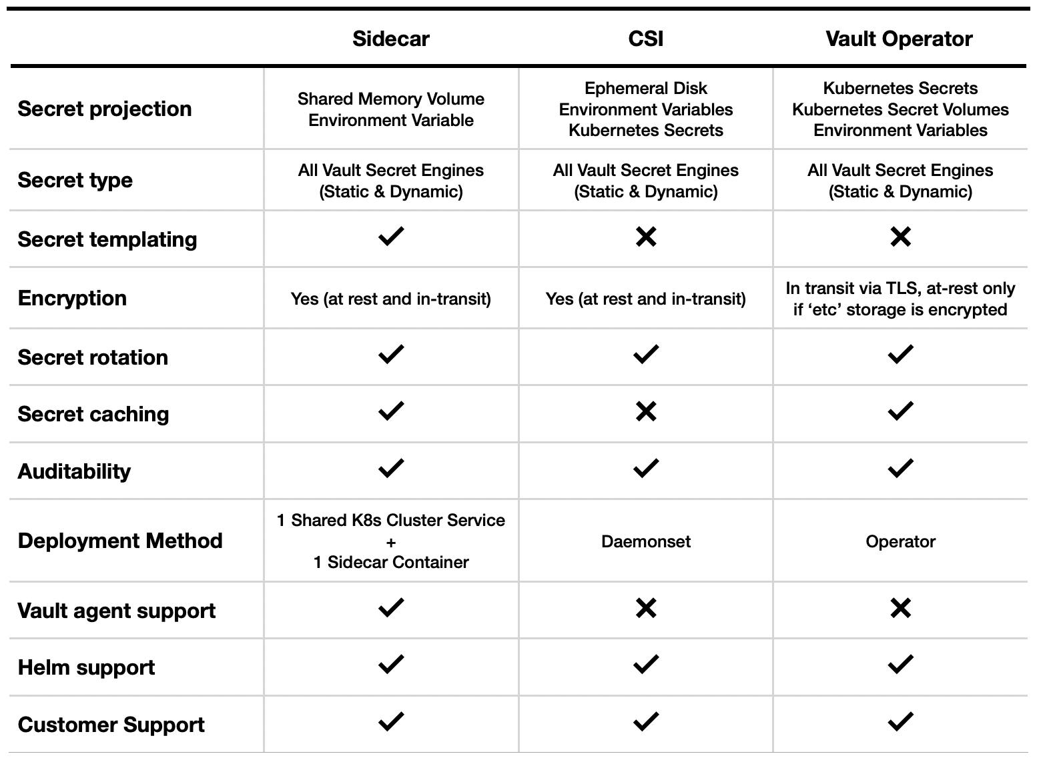

Example Scenario 1
The platform team manages an application on an edge appliance that demands substantial uptime. This application is capable of reading secrets from a CSI volume and can fetch updates without necessitating a pod restart. After evaluating the available options, a sidecar proves to be too resource intensive, and the appliance does not contain multiple Kubernetes nodes so a rolling update is not an option. Ultimately the team settles on the CSI driver for the ability to keep their application up when secrets are updated.

Example Scenario 2
A platform team wants to leverage multiple Vault instances, and requires the ability to connect to multiple namespaces to retrieve secrets for their applications. They also need to leverage their AWS credentials to authenticate to Vault. The team decides quickly on VSO for its ability to render as native Kubernetes secrets, perform rolling updates, and leverage AWS credentials.

Additional References

- Kubernetes Vault integration via Sidecar Agent Injector vs. Vault Secrets Operator vs. CSI provider
- VSO Announcement Blog
- Kubernetes documentation about Rolling Updates
- Sidecars and DaemonSets: Battle of containerization patterns

